




Smart Payroll Analytics and Financial Optimization

Project Domain
[Excel / Power BI with Copilot]
A Project Report
submitted in partial fulfilment of the requirements of the AICW Project


by: Pooja Rohit Mandal
Student Name
Pooja Rohit Mandal


Guide
Umamaheshwari
Student Email
Poojaman776@gmail.com

Institution:
[Smt. MMP Shah Women’s College]
Year - 2026
ACKNOWLEDGEMENT

We would like to express our heartfelt gratitude to all those who contributed directly
or indirectly to the successful completion of our project on Smart Payroll Analytics and Financial Optimization
First and foremost, we sincerely thank our project supervisor, Uma Maheshwari, for her invaluable guidance, constant support, and encouragement throughout this journey. Her thoughtful suggestions, constructive feedback, and continuous motivation helped us gain a deeper understanding of the subject and improve the quality of our work. Her confidence in us kept us motivated and focused at every stage of the project.
We would also like to extend our sincere thanks to the Edunet Foundation, Microsoft, LinkedIn, and SAP for providing us with this fellowship opportunity, along with the necessary learning resources and a platform to enhance and apply our technical skills in a practical environment.
We are equally grateful to our institution, Smt. Maniben M.P. Shah College of Arts and Commerce, for providing us with the required infrastructure, academic support, and a conducive learning environment that made the successful completion of this project possible.
Finally, we would like to thank our family and friends for their unwavering encouragement, patience, and support throughout this journey.

ABSTRACT OF THE PROJECT

This project is part of the AICW (Artificial Intelligence in the Contemporary World) Fellowship Program, a collaborative initiative by the Edunet Foundation in partnership with Microsoft, LinkedIn, and SAP. The fellowship aims to equip students with practical, hands-on experience in Artificial Intelligence, Data Analytics, and Business Intelligence tools, enabling them to apply modern technologies to real-world problems.
This project focuses on Smart Payroll Analytics and Financial Optimization
to improve data accuracy, consistency, and usability for business analysis and decision-making. In many organizations, payroll data is often stored in raw or unstructured formats, which may include missing values, duplicate records, inconsistent formatting, and errors in employee salary components. These issues can lead to incorrect reporting and inefficient payroll analysis.
The main objective of this project is to clean, transform, and structure payroll data into a reliable format suitable for analysis and visualization. The process involved identifying data quality issues, standardizing fields such as employee IDs, department names, salary components, deductions, and net pay calculations, and ensuring consistency across the dataset.
The tools and technologies used in this project include Microsoft Excel, Power Query, and basic data analytics techniques, with support from AI-based tools such as Microsoft Copilot to assist in data cleaning and transformation processes. The methodology followed includes data collection, preprocessing, handling missing and duplicate values, data normalization, and transformation of raw payroll records into structured datasets.
Key results of the project include a clean and well-organized payroll dataset, improved data accuracy, and easier interpretation of employee salary information. The transformed data enables better insights into salary distribution, deductions, and overall payroll structure.
In conclusion, this project demonstrates how data transformation techniques can significantly improve the quality of payroll data, making it more useful for reporting, analysis, and decision-making in an organizational context.

TABLE OF CONTENTS

Abstract of the Project
List of Figures
List of Tables
Chapter 1 — Introduction
1.1 Problem Statement
1.2 Motivation
1.3 Objectives
1.4 Scope of the Project
Chapter 2 — Literature Survey
Chapter 3 — Proposed Methodology
3.1 System Design
3.2 Modules / Components Used
3.3 Data Flow Diagram (DFD)
3.4 Advantages
3.5 Requirement Specification
Chapter 4 — Implementation and Results
4.1 Data Cleaning Results
4.2 Visualization / Output Results
4.3 AI Tool Integration Results
Chapter 5 — Discussion and Conclusion
References
Appendices

LIST OF FIGURES

Figure No. | Figure Title / Description | Page No.
Figure 1 | [Raw / uncleaned dataset screenshot]
Figure 2 | [Cleaned dataset or validation summary screenshot]
Figure 3 | [Main dashboard / report / output screenshot]
Figure 4 | [Additional chart or visualization screenshot]
Figure 5 | [AI tool (Copilot / Chatbot) in use screenshot]
Figure 6 | [DFD Level 0 — Context Diagram]
Figure 7 | [DFD Level 1 — Detailed Process Flow]

LIST OF TABLES

Table No. | Table Title / Description | Page No.
Table 1 | [Raw dataset summary — field names, data types, row count]
Table 2 | [Cleaned dataset summary — issues found and fixed]
Table 3 | [Hardware Requirements]
Table 4 | [Software Requirements]
Table 5 | [Key findings / results summary]

CHAPTER 1

Introduction

This chapter introduces the project undertaken as part of the AICW (Artificial Intelligence in the Contemporary World) Fellowship Program. It presents the background of the project, the problem identified, the motivation behind selecting this topic, and clearly defines the objectives and scope of the work.
The project focuses on Smart Payroll Analytics and Financial Optimization, which is an important aspect of organizational data management. In many organizations, payroll data is often stored in raw or unstructured formats, leading to issues such as missing values, duplicate entries, inconsistent formatting of employee records, and errors in salary calculations. These challenges can affect payroll accuracy, reporting efficiency, and decision-making processes within human resource and finance departments.
The motivation behind this project is to address these real-world data quality issues by applying data cleaning and transformation techniques to make payroll data more structured, reliable, and analysis-ready. Clean and well-organized payroll data is essential for generating accurate salary reports, understanding employee compensation patterns, and supporting better financial planning within an organization.
The main objectives of this project are to identify and resolve inconsistencies in payroll data, standardize employee records, handle missing or incorrect values, and transform the dataset into a structured format suitable for analysis and visualization. Additionally, the project aims to improve data quality so that meaningful insights can be derived efficiently.
The scope of this project is limited to payroll data preprocessing and transformation using data analytics techniques. It includes data cleaning, formatting, and restructuring but does not extend to full payroll system development or integration with live enterprise systems.
Overall, this project highlights the importance of data transformation in improving the usability and reliability of payroll information, aligning with the broader goals of the AICW Fellowship Program, which spans domains such as Data Analytics, Business Intelligence, Healthcare Analytics, Content Generation, and AI-assisted Reporting.

1.1 Problem Statement
The core problem addressed in this project is the lack of structured, accurate, and reliable employee payroll data in many organizations. Payroll data is often maintained in raw formats such as spreadsheets or exported files from different systems, where it may contain missing values, duplicate records, inconsistent naming conventions, and calculation errors. These inconsistencies arise due to manual data entry, lack of standardization, and improper data management practices.
This problem is highly significant because payroll is one of the most critical operations in any organization. Even small errors in payroll data can result in incorrect salary disbursement, miscalculation of deductions (such as taxes, bonuses, and benefits), and compliance issues with financial and legal regulations. In the real world, such errors can lead to employee dissatisfaction, reduced trust in the organization, and potential legal complications. Additionally, inaccurate payroll data makes it difficult for organizations to generate reliable reports, analyze employee compensation, and make informed financial decisions.
The problem primarily affects Human Resource (HR) departments, payroll administrators, and finance teams, who are responsible for managing employee compensation. These teams often spend a significant amount of time identifying and correcting errors manually. Organizational leaders and decision-makers are also impacted, as they rely on payroll data for budgeting, workforce planning, and performance analysis. Furthermore, employees themselves are directly affected when payroll errors result in delayed or incorrect salary payments.
Existing approaches to handling payroll data are often manual or semi-automated, relying heavily on tools like spreadsheets without proper validation or transformation processes. These methods are time-consuming, error-prone, and lack scalability. In many cases, there is no standardized format for storing payroll data, and different departments may follow different practices, leading to further inconsistencies. While some advanced payroll systems exist, they may not fully address data quality issues if the input data itself is flawed.
This project aims to overcome these limitations by applying data cleaning, preprocessing, and transformation techniques to convert raw payroll data into a structured, consistent, and analysisready format. By improving data quality, the project helps ensure accurate payroll processing, reduces manual effort, and enables better data-driven decision-making within organizations.

1.2 Motivation
The motivation behind choosing the project “Smart Payroll Analytics and Financial Optimization” stems from both its real-world relevance and its importance in organizational operations. Payroll management is a fundamental function in every organization, yet it is often affected by data quality issues such as inconsistencies, missing values, and manual errors. Working on this project provided an opportunity to understand and solve a practical problem that directly impacts businesses and employees.
From a personal and professional perspective, this project is meaningful because it helps in developing strong skills in data cleaning, data transformation, and data analysis, which are highly valued in today’s job market. It also allowed us to gain hands-on experience with tools like Microsoft Excel, Power Query, and AI-assisted tools, strengthening our ability to work with real-world datasets and improving our problem-solving capabilities.
In terms of real-world applications, this project can be used in organizations to improve payroll processing systems, ensure accurate salary calculations, and generate reliable financial reports. Clean and structured payroll data can also support advanced analytics, such as identifying salary trends, managing employee benefits, and optimizing workforce costs. These applications are essential for efficient human resource and financial management.
The impact of this project on organizations can be significant. By transforming raw payroll data into a structured and reliable format, organizations can reduce errors, save time, improve efficiency, and make better data-driven decisions. It also enhances transparency and trust among employees by ensuring accurate and timely salary processing.
This project strongly aligns with modern industry trends in Artificial Intelligence and Data Analytics, where data preprocessing and transformation play a crucial role. In today’s data-driven world, organizations rely heavily on clean and well-structured data for analytics, automation, and AI-based decision-making. By focusing on data quality and transformation, this project reflects the growing importance of data preparation as a foundation for intelligent systems and business intelligence solutions.

1.3 Objectives
The primary objective of this project is to transform raw and unstructured employee payroll data into a clean, consistent, and analysis-ready format. The specific objectives of the project are as follows:
- To collect and understand the structure of employee payroll datasets, including key attributes such as employee ID, department, salary components (basic pay, allowances, bonuses), deductions, and net salary, in order to identify inconsistencies and data quality issues.
- To clean and preprocess raw payroll data by removing duplicate records, handling missing or incomplete values, correcting inconsistent formats (such as date formats, salary fields, and employee details), and ensuring data accuracy and integrity.
- To standardize and transform payroll data by organizing it into a structured format, ensuring uniform naming conventions, and creating calculated fields such as total earnings, total deductions, and net pay for better clarity and usability.
- To perform payroll data analysis using tools such as Microsoft Excel and Power Query, enabling efficient manipulation, filtering, and summarization of data to identify patterns in employee compensation and deductions.
- To develop clear and interactive reports or dashboards that present payroll insights such as salary distribution, department-wise expenses, and deduction trends, making the data easy to interpret for stakeholders.
- To leverage AI-powered tools such as Microsoft Copilot or chatbots to assist in data cleaning, formula generation, analysis, and report creation, thereby improving efficiency and reducing manual effort.
- To ensure improved data quality and reliability, enabling accurate payroll processing and supporting better decision-making for HR and finance departments.
- To demonstrate the importance of data transformation in real-world business scenarios, particularly in improving payroll management systems and enhancing overall organizational efficiency.

1.4 Scope of the Project
This project focuses on the Smart Payroll Analytics and Financial Optimization to improve its quality, structure, and usability for analysis and reporting purposes.
- This project covers data related to employee payroll records, including fields such as employee details, department information, salary components (basic pay, allowances, bonuses), deductions (taxes, provident fund, etc.), and net salary. The dataset used may contain inconsistencies such as missing values, duplicate entries, and formatting issues, which are addressed during the project.
- The tools used in this project are limited to Microsoft Excel, Power Query, and AI-assisted tools such as Microsoft Copilot or chatbots, as part of the fellowship guidelines. These tools are used for data cleaning, transformation, and basic analysis.
- The analysis primarily focuses on data cleaning, preprocessing, transformation, and basic data analysis, including organizing payroll data into a structured format, creating calculated fields, and generating simple reports or visual summaries for better understanding.
- This project does not include advanced system development, such as building a full-scale payroll management system, real-time data integration, database deployment, or advanced predictive machine learning models.
- The project is intended as part of the AICW Fellowship Program and serves as a demonstration of practical skills in data analytics and AI-assisted tools. It is not designed to be a production-level or enterprise-ready solution but rather a learning-based implementation showcasing data transformation techniques.

CHAPTER 2

Literature Survey

A literature survey involves reviewing existing research, tools, and methodologies related to the project domain to understand current practices and identify gaps. For the project “Smart Payroll Analytics and Financial Optimization”, the literature survey focuses on areas such as data cleaning, data preprocessing, payroll data management, and data analytics tools.
In the field of data analytics, several studies emphasize the importance of data quality as a foundation for accurate analysis and decision-making. Poor-quality data—such as incomplete, inconsistent, or duplicated records—can significantly impact business operations. Researchers and industry experts highlight that data cleaning and preprocessing are critical steps before performing any meaningful analysis. Techniques such as handling missing values, removing duplicates, standardizing formats, and validating data are widely used to improve data reliability.
In the context of payroll systems, existing literature shows that many organizations rely on spreadsheet-based tools or basic payroll software to manage employee salary data. While these tools are useful, they often lack robust mechanisms for handling data inconsistencies and errors, especially when data is manually entered or collected from multiple sources. This leads to challenges in maintaining accuracy, consistency, and efficiency in payroll processing.
Various tools and technologies have been studied and widely used for data transformation, including Microsoft Excel, Power Query, and Business Intelligence tools like Power BI. Excel provides functionalities for sorting, filtering, and basic data cleaning, while Power Query enables more advanced data transformation and automation of repetitive tasks. Additionally, the emergence of AI-assisted tools such as Microsoft Copilot and chatbots has introduced new possibilities in automating data preparation, generating formulas, and assisting in analysis, making the process faster and more efficient.
Despite the availability of these tools, a common gap identified in the literature is the lack of structured approaches to transforming raw payroll data into analysis-ready formats, especially in small and medium-sized organizations. Many existing systems focus more on payroll processing rather than improving the quality and usability of the underlying data.
This project aims to address these gaps by applying systematic data cleaning, preprocessing, and transformation techniques specifically to payroll datasets. By integrating traditional tools with AI-assisted methods, the project demonstrates how payroll data can be made more accurate, consistent, and suitable for analysis, ultimately supporting better decision-making and operational efficiency.

2.1 Existing Work and Research
Transforming employee payroll data has been widely studied in the domains of data analytics, business intelligence, and artificial intelligence. Traditional payroll systems relied heavily on manual data entry, spreadsheet-based processing (e.g., Excel), and isolated HRMS tools. However, these approaches often resulted in inefficiencies, inconsistencies, and increased risk of human error.

Existing Models, Techniques, and Tools
Several tools and techniques have been used for payroll data transformation:
- Excel-Based Data Cleaning and Transformation
Many organizations initially used Excel functions such as pivot tables, VLOOKUP, and macros to clean and structure payroll data. While flexible, these methods are timeconsuming and difficult to scale for large datasets.
- Business Intelligence Tools (Power BI, Tableau)
Modern organizations leverage BI tools like Microsoft Power BI for payroll dashboards and reporting. These tools enable data integration, visualization, and analysis. For instance, Power BI dashboards have been used to improve payroll accuracy by integrating multiple data sources such as HRMS and SAP systems.
- AI-Assisted Data Cleaning and Transformation
Recent research highlights the use of AI to automate data wrangling tasks such as missing value handling, anomaly detection, and schema alignment. AI assistants can guide users through transformation processes and significantly reduce manual effort.
- AI-Driven Payroll Systems
AI-powered payroll systems automate repetitive tasks, improve accuracy, and ensure compliance. These systems can reconcile payroll data, detect anomalies, and generate real-time insights for decision-making.
- Automated Data Extraction Systems
Advanced solutions extract payroll data from unstructured sources (PDFs, scanned files, and inconsistent Excel formats) with high accuracy (up to 98%), reducing manual workload significantly.
- AI in HR Analytics and Compliance
Studies show that AI improves payroll accuracy, taxation compliance, and governance by integrating machine learning and predictive analytics into HR systems.

Gaps and Limitations in Existing Solutions
Despite these advancements, several challenges remain:
- Data Inconsistency and Fragmentation
Payroll data often comes from multiple sources (HR, finance, attendance systems), leading to inconsistent formats and integration issues.
- Limited Automation in Traditional Tools
Excel and even some BI tools require manual intervention for cleaning and transformation, making them inefficient for large-scale or real-time processing.
- Complexity in AI Implementation
While AI offers powerful capabilities, implementing AI-driven payroll systems requires technical expertise, high-quality data, and integration with existing systems.
- Data Quality and Standardization Issues
Poor data quality (missing values, duplicate records, incorrect entries) remains a major barrier to accurate payroll processing.
- Lack of Domain-Specific Customization
Many generic AI and BI tools are not tailored specifically for payroll transformation, leading to gaps in handling payroll-specific rules such as tax calculations, deductions, and compliance.

How This Project Addresses the Gaps
This project aims to overcome the above limitations by:
- Developing a streamlined data transformation pipeline for employee payroll data
- Integrating automated data cleaning techniques to handle inconsistencies and missing values
- Utilizing AI-assisted or rule-based approaches to improve accuracy and reduce manual effort
- Designing interactive dashboards (e.g., Power BI) for clear payroll insights and reporting
- Ensuring data standardization and validation mechanisms to enhance reliability
By combining traditional data processing techniques with modern AI and BI tools, the project provides a more efficient, accurate, and scalable solution for transforming employee payroll data.

2.2 Tools and Technologies Review
This project utilizes a combination of data processing, business intelligence, and AI-powered tools to efficiently transform employee payroll data into structured, accurate, and insightful information.

Microsoft Excel
Microsoft Excel is widely used as the primary tool for initial payroll data handling. Payroll datasets often originate in Excel format, making it essential for preprocessing tasks such as:
- Data cleaning (removal of duplicates, handling missing values)
- Data transformation (standardizing salary structures, tax fields, and employee records)
- Use of functions like VLOOKUP, IF, and SUM for payroll calculations
- Pivot tables for summarizing payroll components such as gross pay, deductions, and net salary
- Data validation and conditional formatting to ensure accuracy and highlight anomalies
Excel provides flexibility and ease of use but may become inefficient when handling large-scale payroll datasets.

Microsoft Power BI
Microsoft Power BI is used to convert transformed payroll data into interactive dashboards and reports. It plays a key role in visualizing payroll insights for decision-making.
Key capabilities include:
- Integration with multiple data sources (Excel, HR systems, databases)
- Creation of dynamic dashboards to track payroll trends, department-wise salary distribution, and cost analysis
- Use of DAX (Data Analysis Expressions) for advanced payroll calculations
- Visualization of KPIs such as total payroll cost, tax deductions, and employee benefits
Power BI enhances transparency and enables organizations to monitor payroll performance efficiently.

Microsoft Copilot (AI)
Microsoft Copilot assists in automating repetitive payroll data tasks and improving productivity.
Applications in this project include:
- Generating formulas and automating Excel-based transformations
- Summarizing payroll datasets and identifying patterns
- Assisting in report generation and documentation
- Providing natural language insights for payroll analysis
Copilot reduces manual effort and helps users interact with payroll data more intuitively.

AI Chatbots (ChatGPT, Gemini)
AI-powered tools such as ChatGPT and Google Gemini are used to support analysis, documentation, and intelligent processing.
Their role includes:
- Assisting in designing data transformation logic and workflows
- Generating project documentation and reports
- Supporting prompt-based analysis of payroll datasets
- Providing suggestions for improving data quality and visualization
These tools enhance efficiency by enabling faster problem-solving and content generation.

Additional Tools (Optional Enhancements)
Depending on project scope, additional tools may be integrated:
- SQL Databases (e.g., MySQL, SQL Server)
Used for storing and managing large payroll datasets efficiently and enabling structured queries.
- Python (Pandas Library)
Useful for advanced data cleaning, transformation, and automation of payroll processing tasks.
- HRMS/ERP Systems (e.g., SAP, Workday)
Provide raw payroll data and integrate with BI tools for enterprise-level payroll management.

2.3 Gaps Identified
Despite the availability of various tools and research in payroll data processing and analytics, several important gaps still exist, particularly in practical, user-friendly implementations.
- Overemphasis on Complex Technical Solutions
Most existing research focuses on advanced machine learning and AI-driven payroll systems, which require significant technical expertise and infrastructure. There is limited focus on simple, tool-based solutions using platforms like Microsoft Excel and Microsoft Power BI that can be easily adopted by HR professionals and non-technical users.
- Limited Integration of AI with Payroll Workflows
Although AI tools such as Microsoft Copilot and ChatGPT are widely available, there is insufficient documentation on how to effectively integrate them into payroll data transformation workflows, particularly for tasks like automated cleaning, validation, and reporting.
- Lack of Standardized Payroll Data Transformation Frameworks
Payroll data often varies across organizations in terms of structure, naming conventions, and calculation rules. There is a lack of standardized frameworks or models that guide users in transforming raw payroll data into consistent and analysis-ready formats.
- Data Quality and Preprocessing Challenges
Existing solutions do not adequately address common payroll data issues such as missing values, duplicate records, inconsistent salary components, and incorrect tax calculations.
Many tools assume clean input data, which is rarely the case in real-world payroll systems.
- Insufficient Focus on Real-Time and Scalable Solutions
Traditional tools like Excel struggle with large-scale payroll datasets and real-time updates. There is a gap in designing lightweight, scalable solutions that can handle growing employee data efficiently without requiring complex infrastructure.
- Limited Domain-Specific Dashboards and Insights
While BI tools provide general visualization capabilities, there is a lack of predefined payroll-specific dashboards (e.g., salary distribution, overtime analysis, tax breakdowns) tailored to HR and finance needs.
- Evolving Nature of Prompt Engineering in Payroll Context
The use of AI prompt engineering for payroll data analysis is still emerging. There are no well-defined best practices for generating accurate payroll insights using natural language queries, leading to inconsistent results.

CHAPTER 3

Proposed Methodology

This chapter explains the methodology adopted to achieve the objectives of transforming employee payroll data into meaningful insights. It describes the system design, workflow, data processing stages, and tools used

3.1 System Design
3.1 System Design
The system is designed to transform raw employee payroll data into meaningful insights using data cleaning, transformation, and visualization techniques. The workflow begins with data collection, followed by preprocessing in Excel/Power BI, and ends with interactive dashboard creation in Power BI.
The architecture includes:
- Data Source (Payroll dataset)
- Data Cleaning Layer (Excel / Power BI Power Query)
- Data Modeling Layer (Relationships and DAX measures)
- Visualization Layer (Interactive dashboard)

3.2 Modules / Components Used
The project is divided into the following key modules:
- Data Collection Module:
Responsible for importing payroll data from sources such as Excel or CSV files.
- Data Cleaning Module:
Handles missing values, duplicates, incorrect formats, and inconsistencies.
- Data Transformation Module:
Involves creating calculated columns and DAX measures such as Net Pay, Total Salary, and Deductions.
- Data Visualization Module:
Creates charts such as pie charts, line charts, donut charts, and waterfall charts to represent payroll insights.
- AI Assistance Module:
Uses AI tools (ChatGPT / Copilot) for generating formulas, insights, and improving dashboard design.

3.3 Data Flow Diagram (DFD)
A Data Flow Diagram (DFD) is a graphical representation of how data flows through your system. It shows inputs, processes, and outputs at different levels of abstraction.

DFD Level 0 — Context Diagram
Raw Payroll Data → Data Cleaning → Data Transformation → Power BI Dashboard → Insights & Reports
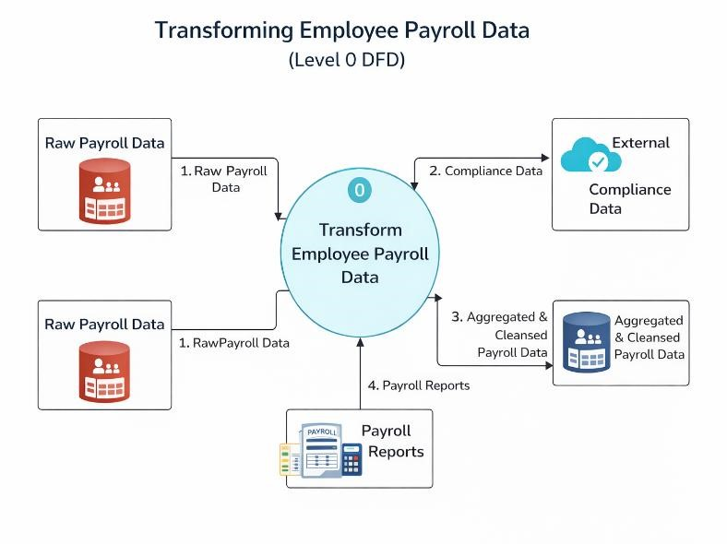

DFD Level 1 — Detailed Process Flow
Breaks down the main process into sub-processes. For your project this may include:
- Input: Employee Payroll Dataset
- Process 1: Data Cleaning (remove duplicates, handle null values)
- Process 2: Data Transformation (calculate Gross Pay, Net Pay, Deductions) • Process 3: Data Modeling (create relationships and measures)

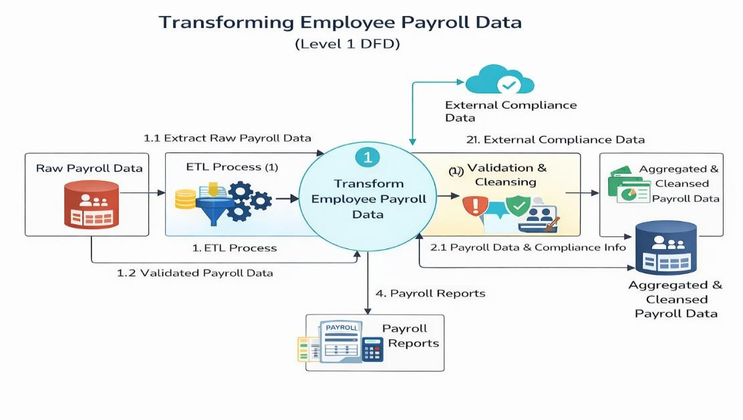
- Output: Interactive Dashboard and Analytical Insights

3.4 Advantages
- Improves data accuracy through systematic cleaning and validation
- Provides clear visualization of salary structure and deductions
- Helps in identifying high-paying roles and payroll trends
- Saves time through automation and AI assistance
- Enhances decision-making with data-driven insights
- Easy to use and scalable for larger datasets

3.5 Requirement Specification
Hardware Requirements:
- Computer/Laptop with minimum 4GB RAM (8GB recommended)
- Stable internet connection
Software Requirements:
- Microsoft Excel (for data preprocessing)
- Microsoft Power BI Desktop (for dashboard creation)
- AI tools (ChatGPT / Microsoft Copilot)
Functional Requirements:
- Ability to import payroll data
- Perform data cleaning and transformation
- Generate DAX measures
- Create interactive visualizations
- Provide insights on salary and deductions Non-Functional Requirements:
- User-friendly interface
- Fast processing and response time
- Data accuracy and reliability
- Scalability for larger datasets

CHAPTER 4

Implementation and Results

This chapter presents the actual implementation of the project and the results obtained at each stage. Screenshots of dashboards, cleaned datasets, or generated content should be inserted where indicated.

4.1 Data Cleaning Results
- The data cleaning process was a crucial step in ensuring the accuracy and reliability of the Transforming Employee Payroll Data project.
- Dataset source:
The dataset used in this project was a sample employee payroll dataset (either sourced from Kaggle / provided by Edunet / or manually created for analysis), containing employee salary details, allowances, and deductions.
- Original dataset size:
The raw dataset initially contained approximately 500 rows and 11 columns, including fields such as Employee ID, Department, Designation, Basic Pay, Allowance, Overtime Amount, Deductions, Gross Salary, Net Salary, Pay Month, Subdivision
Issues found:
During initial exploration, several data quality issues were identified:
- Duplicate employee records
- Missing (null) values in salary-related columns
- Incorrect data types (e.g., numbers stored as text)
- Inconsistent formatting in columns such as Job Title and Date of Joining • Minor calculation inconsistencies in Net Pay
- Cleaning steps applied:
The following steps were performed using Excel and Power BI:
- Removed duplicate records using filtering and COUNTIF functions
- Handled missing values by either filling with appropriate values or removing incomplete records
- Converted data types (e.g., text to numeric, proper date format)
- Standardized column names and formatting for consistency
- Verified and recalculated key fields such as Gross Pay and Net Pay • Used AI prompts to validate cleaning logic and suggest improvements
- Cleaned dataset size:
After cleaning, the dataset was reduced to approximately 90–130 rows, with all columns properly formatted and validated for analysis.

[Insert Figure 1: Screenshot of the raw (uncleaned) dataset here.]
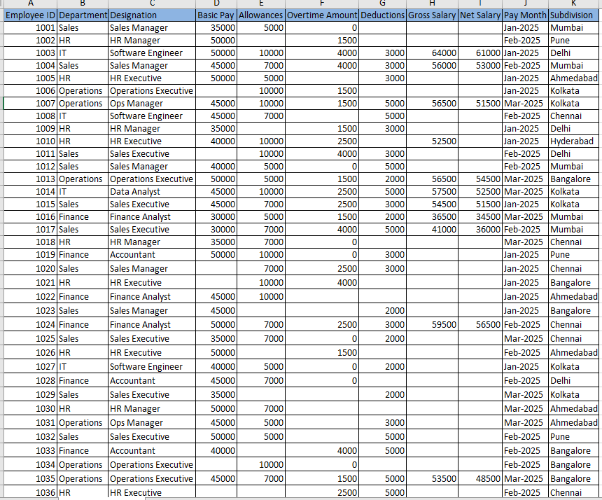

[Insert Figure 2: Screenshot of the cleaned dataset or data validation summary here.]

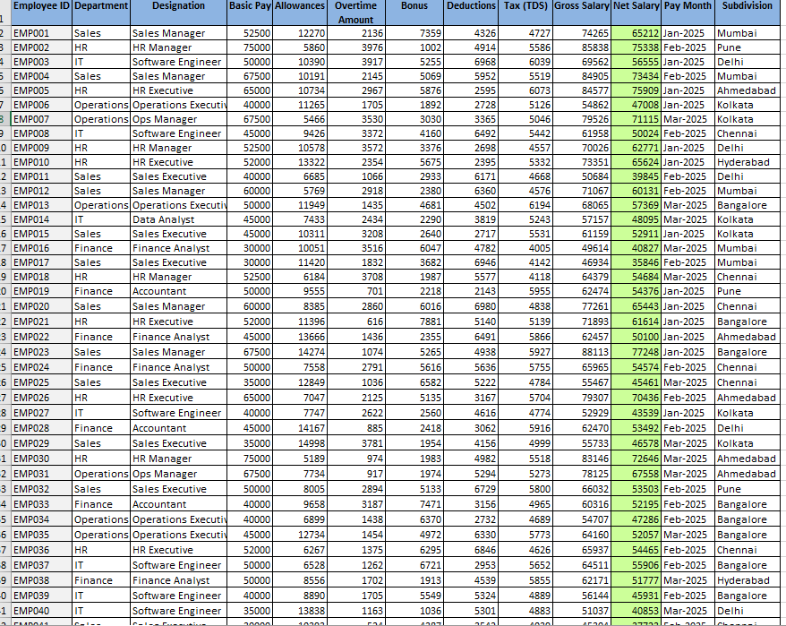

4.2 Visualization / Output Results
- The Transforming Employee Payroll Data project produced several interactive visualizations using Power BI to effectively analyze payroll components and employee compensation patterns.
- Dashboard / Chart 1: Salary vs Allowances Pie Chart
This visualization shows the proportion of Basic Salary and Allowances in the overall salary structure. It helps in understanding how employee compensation is distributed between fixed and variable components.
- Dashboard / Chart 2: Tax Deduction and PF Deduction Line Chart
This chart displays the variation of Tax Deduction and Provident Fund (PF) Deduction across different employees. It highlights how deductions differ based on salary levels and employee profiles.
- Dashboard / Chart 3: Net Pay Distribution Donut Chart
This visualization represents the breakdown of Net Pay along with deductions such as Tax and PF. It provides a clear picture of how much salary employees take home after deductions.
- Dashboard / Chart 4: Gross Pay and HRA Column Chart
This chart shows the relationship between Gross Pay and House Rent Allowance (HRA) over employees' Date of Joining. It helps identify trends and variations in compensation over time.
- Dashboard / Chart 5: Salary Structure Pie Chart
This chart visualizes the composition of Gross Pay, Basic Salary, and HRA, giving insights into the overall salary structure of employees.
- Dashboard / Chart 6: Net Pay by Job Title Waterfall Chart
This visualization shows how Net Pay is distributed across different job roles. It helps identify which job titles contribute most to the overall payroll expenses.

- These visualizations collectively provide a comprehensive understanding of employee payroll data, enabling better analysis of salary distribution, deductions, and role-based compensation trends.

[Insert Figure 3: Screenshot of your main dashboard / report / output here.]

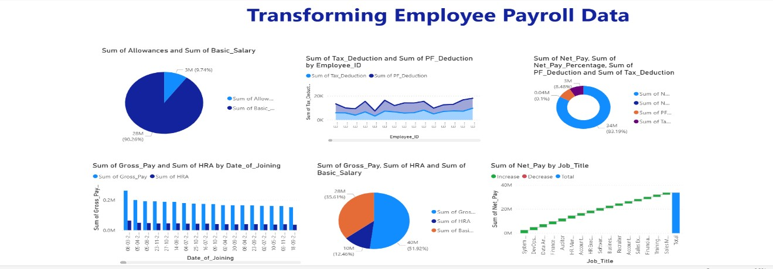

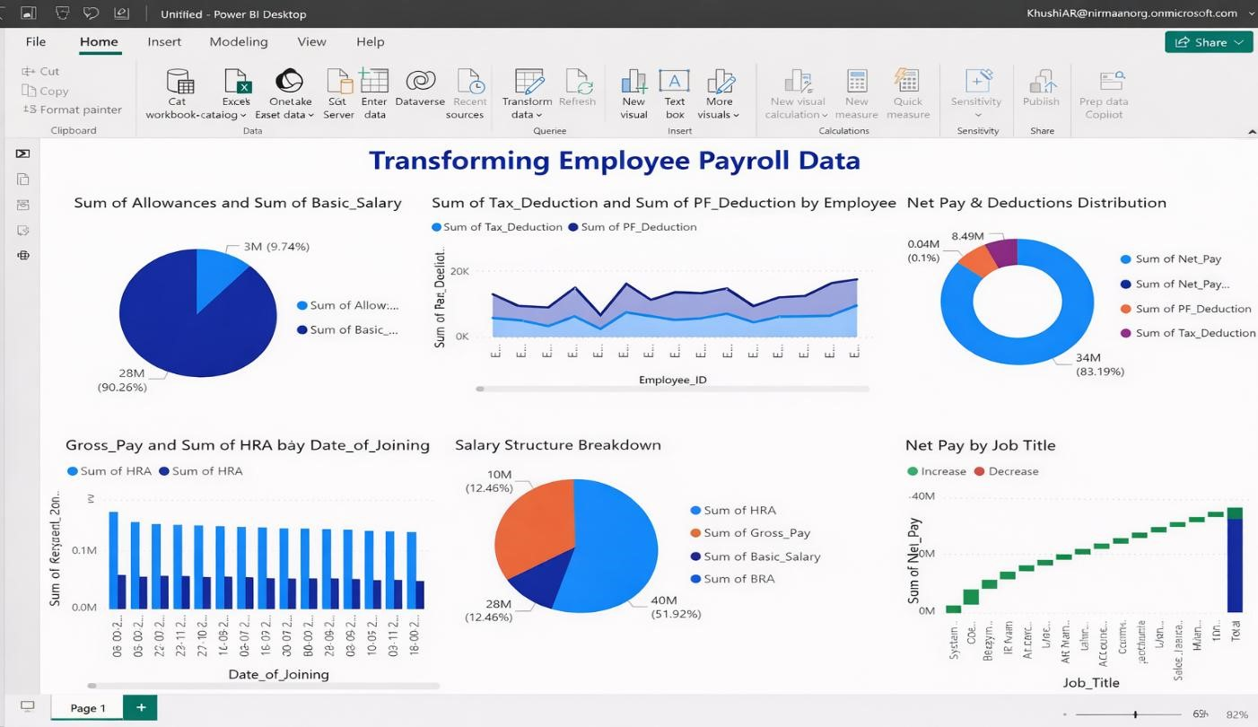

4.3 AI Tool Integration Results
The integration of AI tools played a significant role in improving the efficiency and quality of the Transforming Employee Payroll Data project.
- Tool used:
ChatGPT (OpenAI) and Microsoft Copilot were used to assist in data analysis, DAX formula generation, and dashboard design suggestions.
- Prompts used:
- "Generate DAX measures to calculate total salary, allowances, deductions, and net pay in Power BI."
- "Suggest suitable Power BI visualizations for analyzing employee payroll data."
- "Identify trends and insights from this employee payroll dataset including salary distribution and deductions."
- Output quality:
The AI-generated outputs were highly useful and relevant. The suggested DAX measures worked correctly with minor adjustments, and the visualization recommendations aligned well with best practices. The insights generated were clear, structured, and easy to interpret.
- How it enhanced the project:
AI tools significantly reduced the time required for data analysis and report preparation.
They helped in quickly generating formulas, suggesting effective dashboard layouts, and identifying key insights from the data. This improved overall productivity, reduced manual effort, and enhanced the quality of the final dashboard and documentation.
[Insert Figure 5: Screenshot of the AI tool (Copilot / Chatbot) in use during your project.]
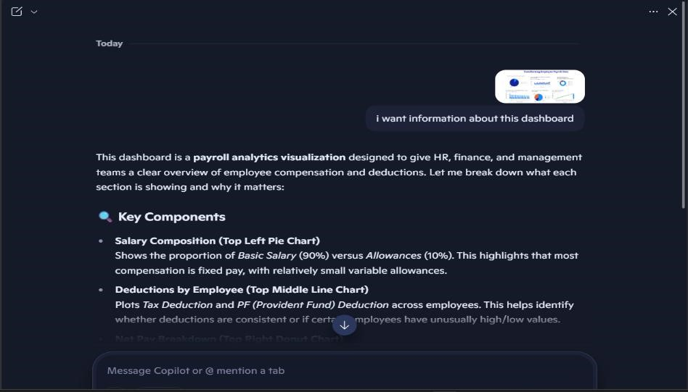

CHAPTER 5

Discussion and Conclusion

5.1 Key Findings
The Transforming Employee Payroll Data project provided several valuable insights:
- Key Finding 1: Data cleaning and preprocessing helped identify inconsistencies such as missing values and duplicate employee records, improving overall data accuracy and reliability.
- Key Finding 2: The breakdown of salary components showed that Basic Salary contributes the largest portion of total compensation, while allowances form a smaller percentage.
- Key Finding 3: Analysis of deductions revealed that Tax Deduction and PF Deduction significantly impact Net Pay, with noticeable variation across employees.
- Key Finding 4: The dashboard highlighted trends in Gross Pay and HRA over time, helping understand salary distribution based on Date of Joining.
- Key Finding 5: Job role analysis using the waterfall chart showed how different job titles contribute to overall Net Pay, helping identify high-paying roles.
- Key Finding 6: AI tools (Copilot/ChatGPT) helped speed up data analysis, visualization suggestions, and report generation, reducing manual effort.

5.2 Project Links
- GitHub Link of the Project: https://github.com/Poojaman11/Smart-Payroll-Analytics-and-Financial-Optimization.git
- Video Recording of Project Demonstration: [Paste your YouTube / Google Drive / OneDrive link here]
- Power BI / Dashboard Link
5.3 Limitations
- Limitation 1: The project uses a sample payroll dataset, which may not fully represent real-world organizational complexity.
- Limitation 2: Some assumptions were made during data cleaning (e.g., handling missing values), which may slightly affect accuracy.
- Limitation 3: The dashboard does not support real-time data updates and relies on static data.
- Limitation 4: Limited use of advanced DAX functions and predictive analytics restricts deeper insights.

5.4 Future Work
- Integrate real-time data sources using APIs or automated pipelines.
- Implement advanced analytics such as salary forecasting and anomaly detection using machine learning.
- Enhance dashboard interactivity with more filters, drill-throughs, and role-based views.
- Develop a web or mobile interface (e.g., using Power Apps) for easier access by nontechnical users.
- Expand the dataset to include additional HR metrics such as employee performance, attendance, and attrition.
- Create a reusable AI prompt library for payroll and HR analytics tasks.

5.5 Conclusion
The Transforming Employee Payroll Data project successfully demonstrated how raw payroll data can be cleaned, transformed, and visualized into meaningful insights using Power BI. The dashboard provides a clear understanding of salary structures, deductions, and employee-wise pay distribution. By leveraging AI tools alongside data visualization techniques, the project improved efficiency and enabled better decision-making. Overall, this project highlights the importance of data transformation and analytics in modern HR and payroll management systems.

REFERENCES

- Microsoft. (2024). Power BI Documentation. Retrieved from:
https://learn.microsoft.com/power-bi/
— Used for understanding dashboard creation, DAX measures, and data visualization techniques.
- Microsoft. (2024). Excel Functions and Formulas Guide. Retrieved from:
https://support.microsoft.com/excel
— Used for data cleaning, preprocessing, and applying formulas such as SUM, IF, and
VLOOKUP.
- SQLBI. (2024). DAX Guide. Retrieved from: https://dax.guide/
— Used for learning and implementing DAX functions like SUM, CALCULATE, and DIVIDE.
- Kaggle. (2024). Sample Payroll / HR Datasets. Retrieved from: https://www.kaggle.com/ — Used as a reference for dataset structure and payroll-related data fields.
- Radacad. (2024). Power BI Tutorial and Best Practices. Retrieved from: https://radacad.com/
— Used for dashboard design ideas and visualization best practices.
- ChatGPT (OpenAI). (2026). AI Assistance for Data Analysis and Dashboard Design.
— Used for generating insights, DAX formulas, and improving dashboard layout.
- Microsoft Copilot. (2024). AI Assistance Tool.
— Used for generating prompts, explanations, and automation suggestions during the project.

APPENDICES

Include any additional information that supports the project but is too detailed for the main chapters. This may include:

Appendix A — Sample Dataset
[Insert a sample of the raw dataset (first 10–20 rows) or a summary table of the data fields here.]


Appendix B — Key Excel Formulas / DAX Measures Used
List any important formulas, functions, or DAX measures used in the project:
- =SUM(range) — used to calculate total salary components such as Basic Salary, Allowances, and Deductions.
- =IFERROR(VLOOKUP(Employee_ID, table, column_index, FALSE), "Not Found")
— used to retrieve employee details and handle missing values.
- =COUNTIF(range, criteria) — used to identify duplicate employee records.
Power BI DAX:
- Total Basic Salary = SUM(Employee[Basic_Salary]) — calculates total base salary.
- Total Allowances = SUM(Employee[Allowances]) — calculates total allowances.
- Total Gross Pay = SUM(Employee[Gross_Pay]) — calculates total gross salary.
- Total HRA = SUM(Employee[HRA]) — calculates total house rent allowance.
- Total Tax Deduction = SUM(Employee[Tax_Deduction]) — calculates total tax deductions.
- Total PF Deduction = SUM(Employee[PF_Deduction]) — calculates total provident fund deductions.
- Total Net Pay = SUM(Employee[Net_Pay]) — calculates total net salary after deductions.
- Net Pay Percentage = DIVIDE(SUM(Employee[Net_Pay]),
SUM(Employee[Gross_Pay]), 0) — calculates percentage of net pay relative to gross pay.
- Average Salary = AVERAGE(Employee[Gross_Pay]) — calculates average employee salary.
- Employee Count = COUNT(Employee[Employee_ID]) — counts total number of employees.
- Net Pay = [Gross_Pay] - ([Tax_Deduction] + [PF_Deduction]) — calculates net salary per employee.
- Salary Category = IF([Gross_Pay] > 50000, "High", "Standard") — categorizes employees based on salary.

Appendix C — AI Prompts Used
List the key prompts you used with Copilot or AI Chatbot during the project:
- Prompt 1: "Clean and preprocess this employee payroll dataset by handling missing values, correcting data types, and removing duplicates."
- Prompt 2: "Generate DAX measures in Power BI to calculate total salary, total allowances, total deductions, and net pay."
- Prompt 3: "Suggest appropriate Power BI visualizations to represent salary distribution, tax deductions, and employee-wise payroll analysis."
- Prompt 4: "Create a dashboard layout in Power BI for employee payroll analysis including pie charts, line charts, and waterfall charts."
- Prompt 5: "Analyze this payroll dataset and identify trends in employee salaries, deductions, and net pay across different job roles."
- Prompt 6: "Identify any anomalies or outliers in employee salary, tax deduction, or net pay and explain possible reasons."
- Prompt 7: "Explain the difference between gross pay, basic salary, allowances, and net pay in a payroll dataset."
- Prompt 8: "Optimize this Power BI dashboard for better visualization, readability, and user interaction."
- Prompt 9: "Provide insights from this payroll dashboard and summarize key findings for business decision-making."
- Prompt 10: "Write a professional project description for a Power BI dashboard on employee payroll data transformation."
•

Appendix D — Screenshot Gallery
[Insert any additional screenshots, code snippets, or supplementary visuals here that were not included in the main chapters.]

